Assingment-6
Task Description-1 (Classes – Data Validation)
Prompt: name, roll_no, and marks. Add a method is_pass() that returns whether the student has passed (marks ≥ 40).
Code: class Student:

def __init__(self, name, roll_no, marks):

if not isinstance(marks, (int, float)) or not 0 <= marks <= 100:

raise ValueError("Marks must be between 0 and 100.")

self.name = name
self.roll_no = roll_no
self.marks = marks
s
def is_pass(self):
return self.marks >= 40

student1 = Student("sthairya", 101, 75)

print("Name:", student1.name)

print("Roll No:", student1.roll_no)

print("Marks:", student1.marks)

print("Pass:", student1.is_pass())
Output:
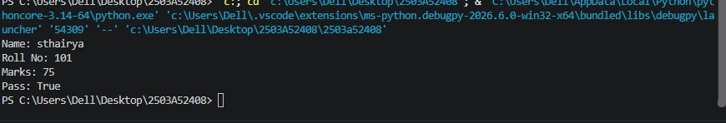
Task Description-2 (Loops – Pattern Generation)
Prompt: Ask AI to generate a function that prints a right-angled triangle star pattern using a for loop. Then regenerate the same pattern using a while loop.
Code: def print_triangle_for_loop(rows):
for i in range(1, rows + 1):
print("*" * i)

#Here is a function that prints a right-angled triangle star pattern using a while loop:
def print_triangle_while_loop(rows):
i = 1
while i <= rows:
print("*" * i)
i += 1
#example usage
print("Triangle using for loop:")
print_triangle_for_loop(5)
print("Triangle using while loop:")
print_triangle_while_loop(5)
Output: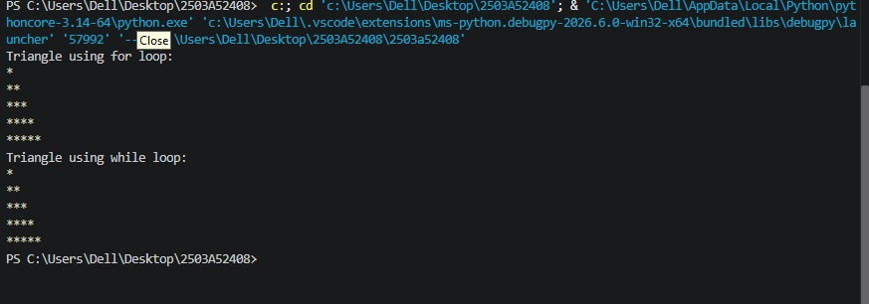 TaskDescription-3 (Conditional Statements – Number Analysis)
Prompt: Ask AI to write a function that checks whether a given number is positive, negative, or zero using if-elif-else. Test the function with multiple inputs
Code: def check_number_sign(number):
if number > 0:
return "Positive"
elif number < 0:
return "Negative"
else:
return "Zero"

#example usage
print(check_number_sign(5)) # Output: Positive
print(check_number_sign(-3)) # Output: Negative
print(check_number_sign(0)) # Output: Zero
Output: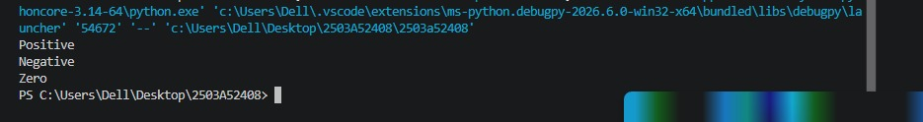

Task Description-4 (Nested Conditionals)
Prompt: Generate a function check_discount(age, is_member) that determines discount eligibility:
Age ≥ 60 → Senior discount
Member → Additional discount
Use nested if statements.
Code:
def check_discount(age, is_member):
if age >= 60:
discount = "Senior discount"
if is_member:
discount += " + Additional member discount"
else:
discount = "No senior discount"
if is_member:
discount += " + Additional member discount"
return discount
#example usage
print(check_discount(65, True)) # Output: Senior discount + Additional member discount
print(check_discount(50, True)) # Output: No senior discount + Additional member discount
print(check_discount(65, False)) # Output: Senior discount
Output:
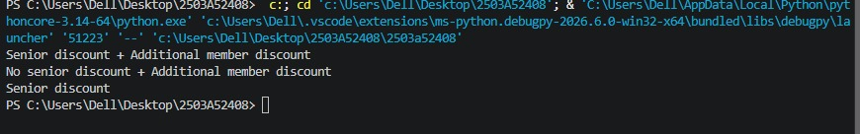
Task Description-5 (Class – Mathematical Opera)
Prompt: Ask AI to create a Circle class with methods to calculate area () and circumference () given the radius.
Code:
import math
class Circle:
def __init__(self, radius):
self.radius = radius

def area(self):
return math.pi * self.radius ** 2

def circumference(self):
return 2 * math.pi * self.radius
#example usage
circle = Circle(5)
print(circle.area()) # Output: 78.53981633974483
print(circle.circumference()) # Output: 31.41592653589793
Output: